VKV GOVERNMENT DEGREE COLLEGE-KOTHAPETA
DEPARTMENT OF COMMERCE
BEST PRACTICES

2024-25

- PG ENTRANCE COACHING FOR OUT GOING STUDENTS

- BOOKS DISTRIBUTION TO STUDENTS

- STUDY HOURS

Signature of In-Charge Signature of Principal

Circular/ Notice
Date:
kothapeta

Vkv Government Degree College, Kothapeta Department of Commerce is going to conducted study hours to B.com students on .So all students preparewell for mid examinations.

Circular to All B.com students:
I b.com(G)&CA
II b.com(G)&CA
III b.com(G)&CA

Signature of Hod Signature of Principal

STUDY HOURS PICS (2024-2025)
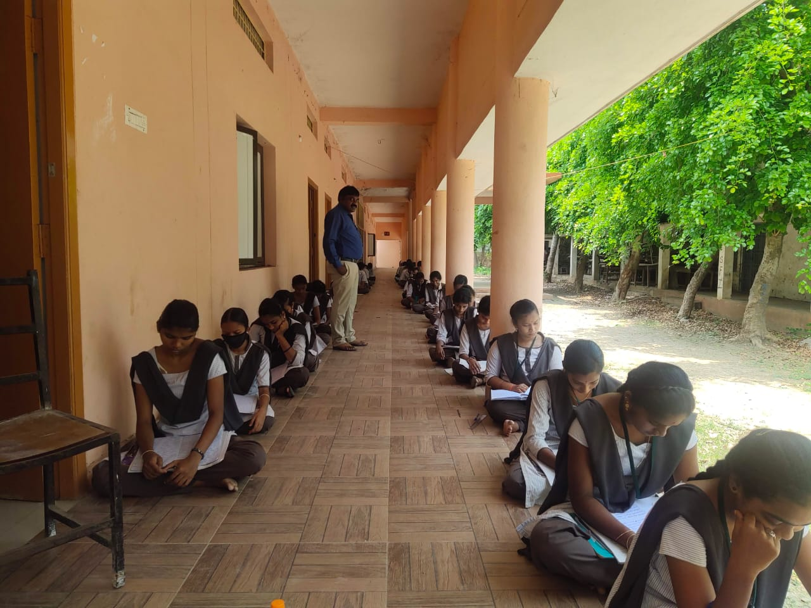

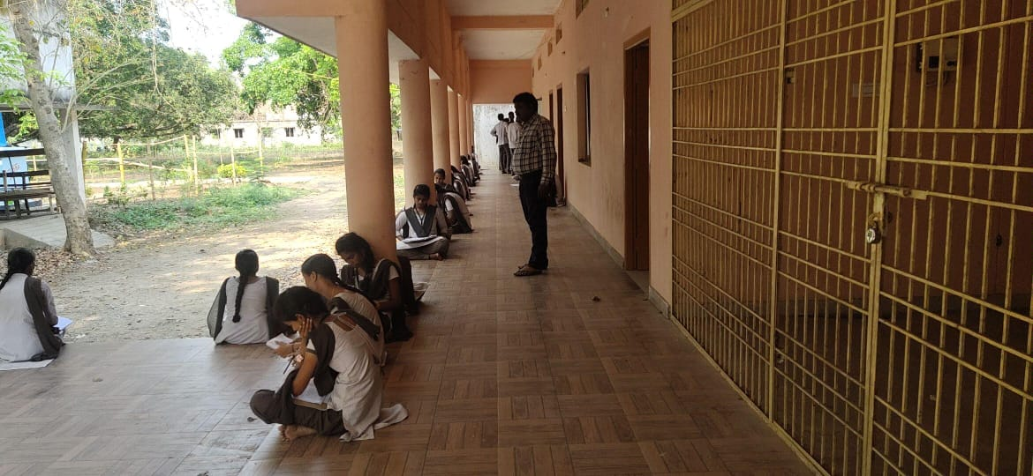

Dr. K.SATYA NARYANA, LECTURER IN COMMERCE CONDUCTED STUDY HOURS FOR III BCOM STUDENTS

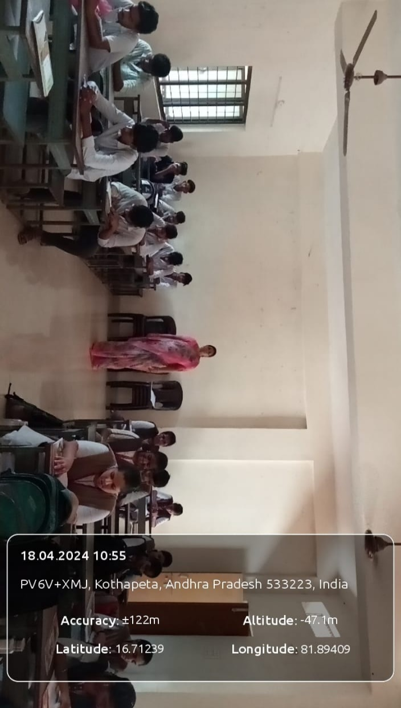

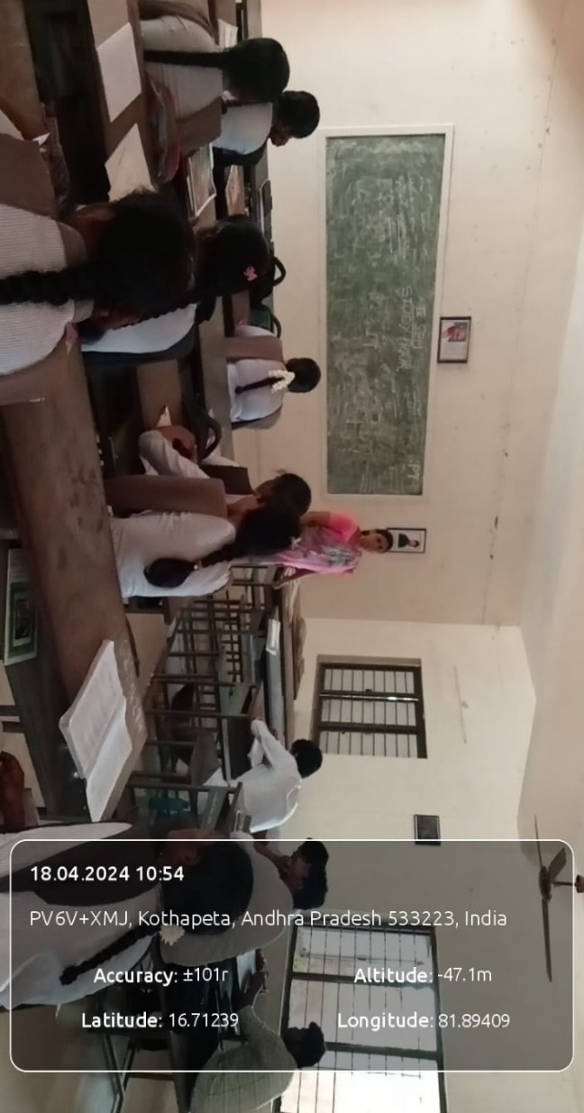

CH.NAGA SRI LAKSHMI,LECTURER IN COMMERCE CONDUCTED STUDY HOUR FOR III B.COM STUDENTS

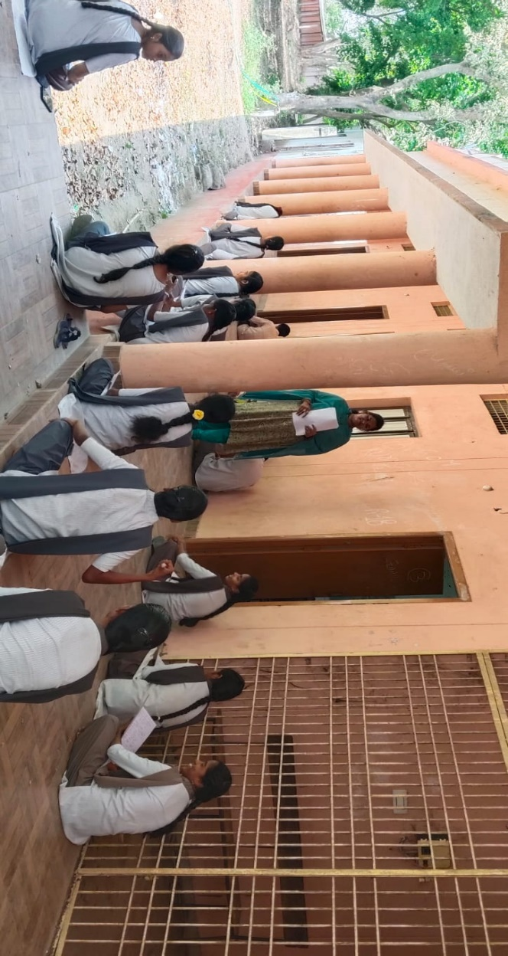
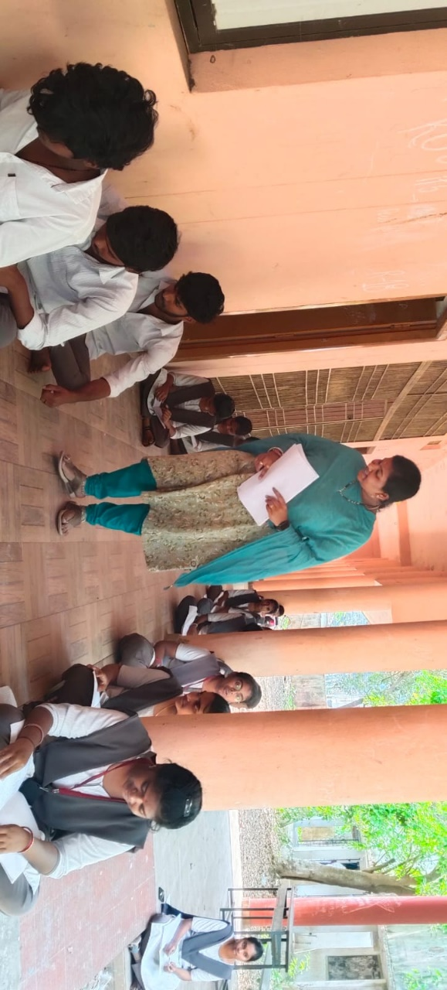

B.SATYA, LECTURER IN COMMERCE CONDUCTED STUDY HOUR FOR IIB.COM STUDENTS
SUBJECT: CORPORATE ACCOUNTING IV SEM

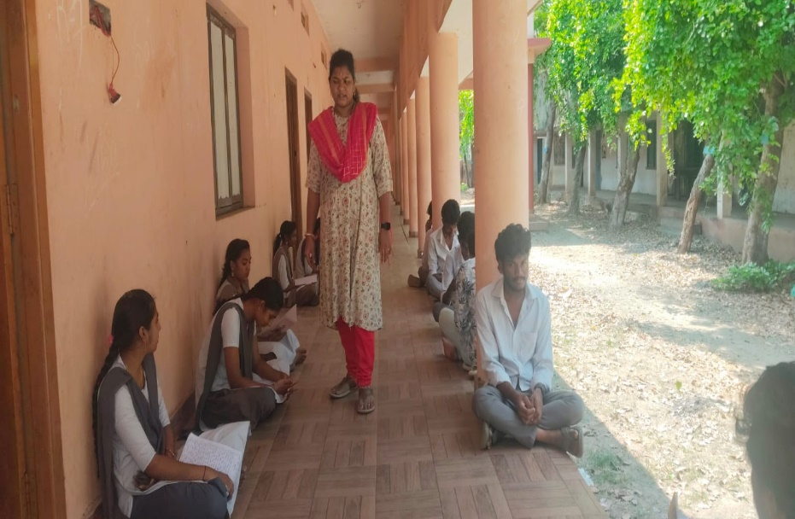

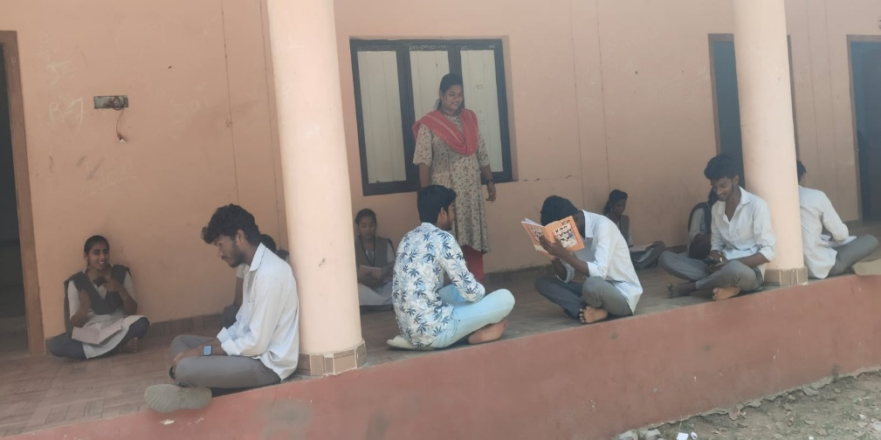

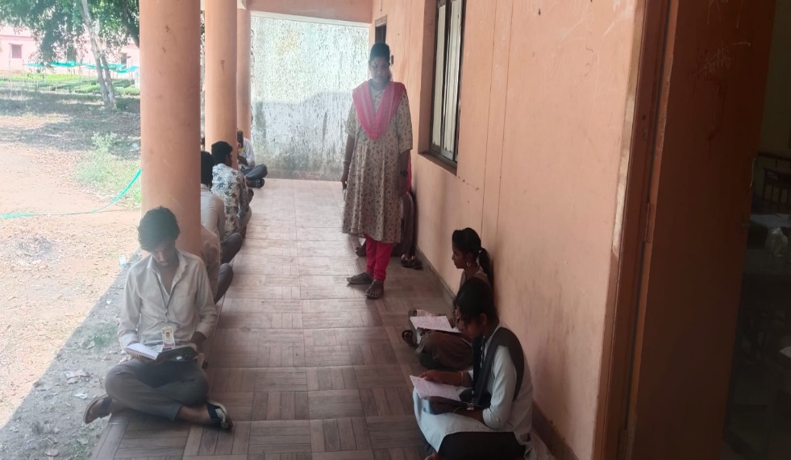

B. SATYA, LECTURER IN COMMERCE CONDUCTED STUDY HOUR FOR IIB.COM STUDENTS
BOOKS DISTRIBUTION
Vkv Government Degree college, Kothapeta Department of commerce is going to Distribute books, study material to economically weaker students.

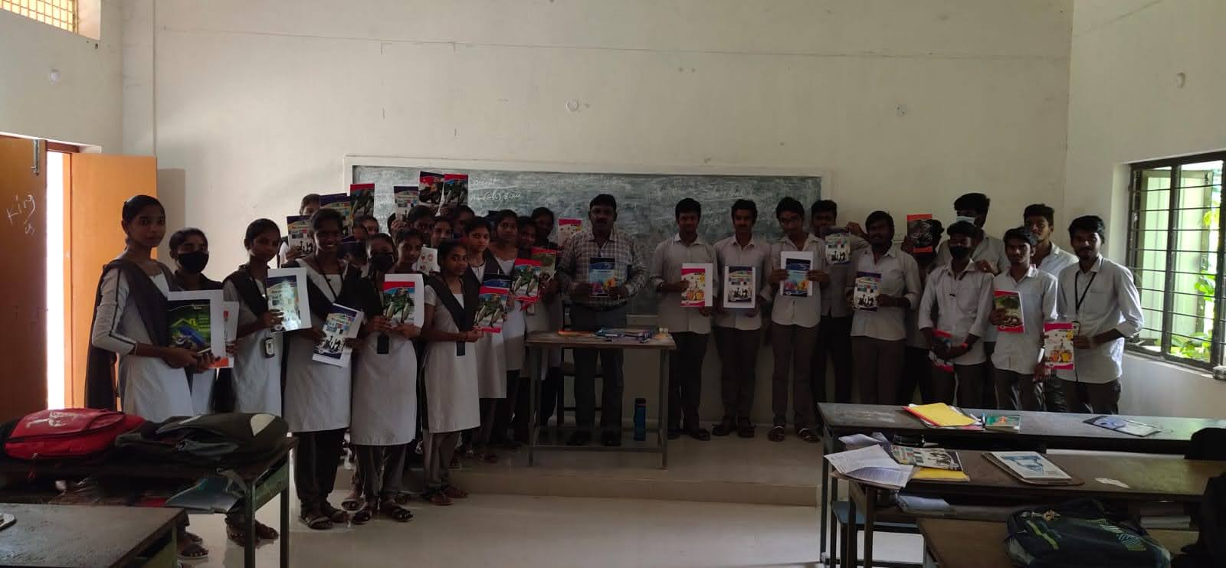

PG RANK HOLDERS 2024-25
Vkv Government Degree college, Kothapeta Department of Commerce take classes for PG Entrance coaching classes for 2023-24 out going students. Totally 10 students got good ranks in APPGCET.
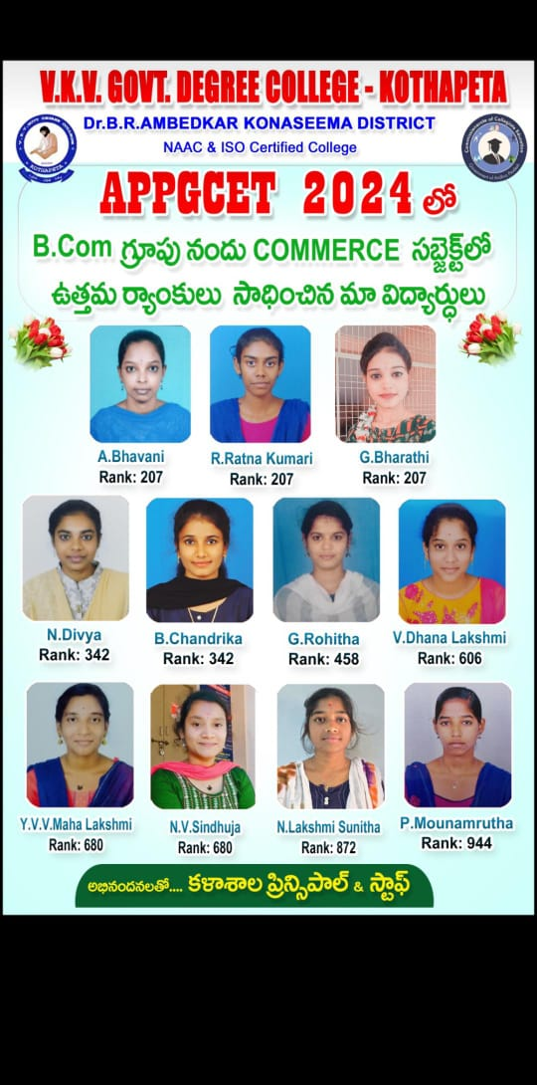

Signature of the in-Charge Signature of principal

